**(Group Member)**

・Eri Arai – 300373936 ・Nijo Jose Pulikkottil – 300374675

・Leung, Kin Shing – 300369660 ・Raina Narayan – 300312305 ・Kotaro Kakuta – 300374601

**・Introduction**

[ Theme / Content ]

Create a travel agency website to recommend tours of famous tourist spots in Japan and India.

[ Reasons for choosing this theme ]

Our team is composed of members from different countries, so we decided to use this   advantage. As for the website content, we had

other. ideas such as food culture, but decided to write content about tourist tours that would attract web visitors. Regarding the countries

to be introduced, we selected Japan and India which are visited by many people because of their many appealing tourist spots. Using the

skills we have learned so far, we worked hard to create a website that would appealingly convey the tours of these two countries.

**・Website layout**

The layout was implemented using the Flexbox layout model and media queries, as specified in the CSS code. Flexbox is a

powerful and flexible layout model that allows elements to be arranged in a flexible manner, regardless of the size of the

container they are placed in. It enables responsive design and makes it easy to create layouts that can adapt to different screen

sizes. Media queries allow developers to apply different styles to the page based on the device or screen size. In the project,

there are two media queries used to adjust the layout of the page for smaller screens. The first media query applies when the

screen size is less than or equal to 768px and adjusts the layout of the form to take up the full width of the screen. The second

media query applies when the screen size is greater than 768px and adjusts the size of the form to be 30% of the container.

**Page 1**

**Page 2**

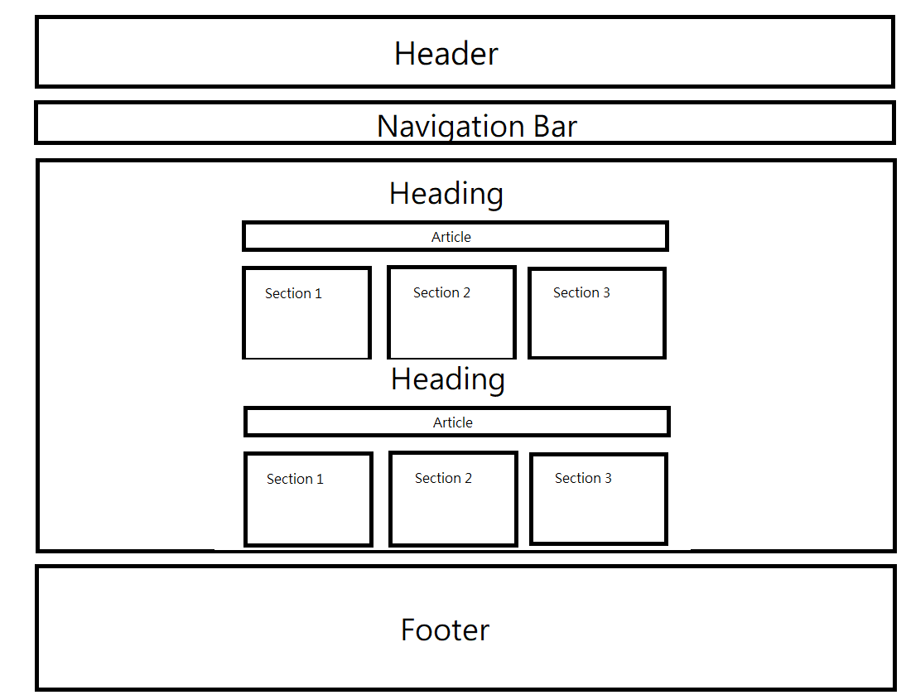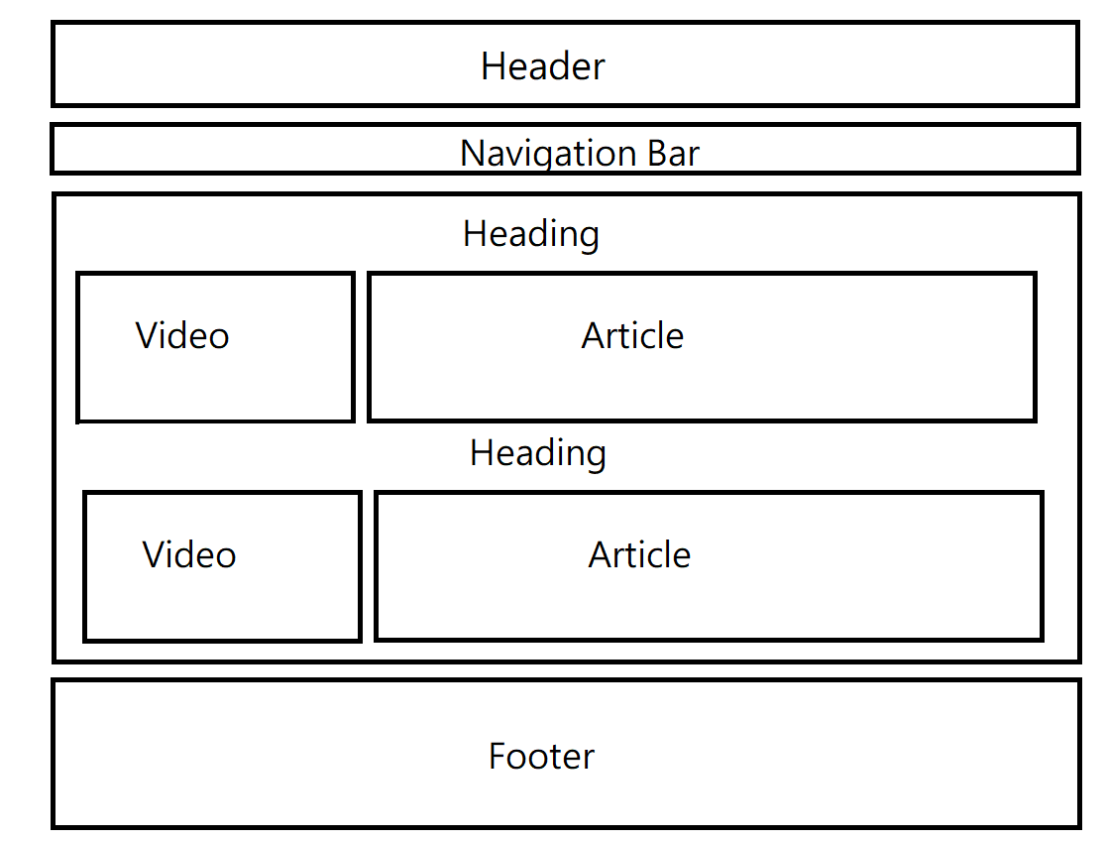

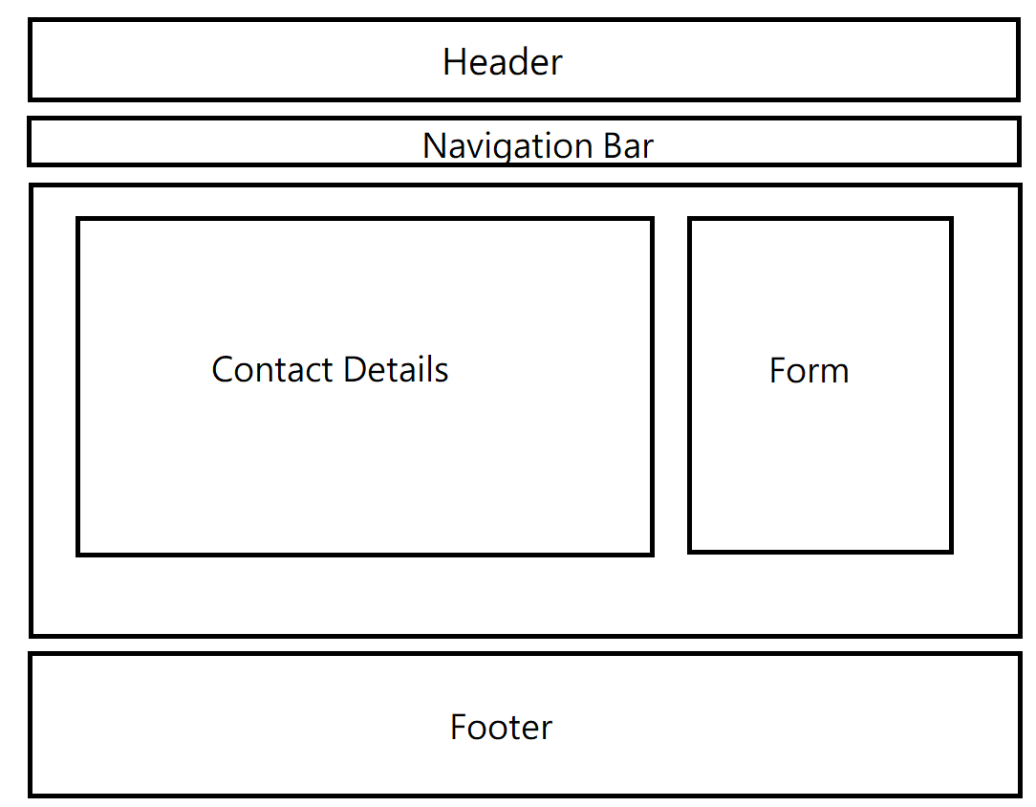

**Page 3**

**・Website organization**

Our home page layout, in terms of its navigation, has been designed to provide users with the utmost ease and efficiency. Each section of the website includes a navigation menu, allowing users to easily navigate through different pages of the website. In addition to the navigation hub, our site, providing an overview of its content, advertises a specific promotion— the promotion of the unique cultures encompassed by Japan and India, two beautiful countries— to the users' inquiry. We described the two countries in brief summaries accompanied by a visual representation, aiming to bring the two dynamic cultures to the screen for users to engage upon.

The second page features an overview of the various tours, present in both Japan and India, available for tourists to partake in. We provided package deals, each consisting of an itinerary of the duration of one's stay alongside the expenses. Similarly, to the first page, the second page of our website includes a summary, highlighting intriguing details of what each country has to offer to its visitors, with a goal to spark an interest in individuals for a future visit. On the other hand, each card frame has JavaScript embedded into them, showcasing specific pictures each package has to offer. Likewise, on the top right, a currency conversion feature has been incorporated, allowing potential users to compare the prices amongst differing currencies. Additionally, we constructed a JavaScript file, allowing the automatic display of images and currencies from other countries.

Lastly, our third page serves as a source for contact information. As users engage on our previous pages, any curiosity or inquiries can be addressed by directly contacting the company through a range of options— emails, phone numbers, addresses, etc. If a desire to travel to either country arises, a sign-up form has also been featured on this page for users to interact with. The sign-up feature uses JavaScript to mimic an authentic and professional-looking form. In addition, if any part of the form has been filled incorrectly, a pop-up message will immediately follow. Once all the fields have been filled in correctly, the submit button will display a popup image on the screen. Furthermore, our footer section includes the company’s multiple social media platforms as an additional form of user interaction and customer engagement with the company.

**・Content declaration**

[Photograph of Hokkaido]. (2017). Pixabay. <https://pixabay.com/photos/hokkaido-road-asphalt-concrete-2244242/>

[Photograph of Sushi]. (2015). Pixabay. https://pixabay.com/images/id-620681/

[Photograph of Japan Sapporo]. (2014). Pixabay.<https://pixabay.com/photos/japan-sapporo-hokkaido-357242/>

[Photograph of Kyoto Japan]. (2014). Pixabay.<https://pixabay.com/photos/kyoto-japan-torii-gate-path-2475666/>

[Photograph of Japanese Shrine]. (2016). Pixabay. [https://pixabay.com/images/id-1805865/](https://pixabay.com/photos/kyoto-japan-torii-gate-path-2475666/)

[Photograph of Kyoto Golden Temple]. (2017). Pixabay.<https://pixabay.com/photos/kyoto-golden-temple-kinkaku-ji-2895857/>

[Photograph of Underwater subtropical]. (2022). Pixabay.<https://pixabay.com/photos/underwater-subtropical-coral-7557528/>

[Photograph of Ishigaki Okinawa]. (2018). Pixabay.<https://pixabay.com/photos/ishigaki-okinawa-sea-landscape-3420678/>

[Photograph of turtle]. (2022). Pixabay. https://pixabay.com/images/id-7133765/

[Photograph of Follow us]. Freepik.https://www.freepik.com/free-vector/follow-us_3659137.htm

[TripAdvisor Round Sticker]. (n.d.). Pinterest. <https://www.pinterest.ca/pin/tripadvisor-round-sticker-craft-supplies-diy-custom-design-supply-special--787707791047645917/>

[Twitter logo icon vector image]. (n.d.) VectorStock. <https://www.vectorstock.com/royalty-free-vector/twitter-logo-icon-vector-22390239>

[Instagram Icon Free Vector and PNG]. (n.d.). pngtree. <https://pngtree.com/so/instagram>

[Facebook free icon]. (n.d.). flaticon. <https://www.flaticon.com/free-icon/facebook_124010>

Google. (n.d.) [Google fonts]. <https://fonts.google.com/specimen/Monoton?preview.size=52>

How to Spend 14 Days in Japan Video https://youtu.be/IuTDuvYr7f0

Incredible India Video <https://tourism.gov.in/webcast/incredible-india-directors-cut-travel-cnn>

Incredible India Home Page Content for page 1, para 1  <http://indiatourism.online/>

Brief Intro on India Tourism for page 2, para 4 <https://www.tajmahaltourguide.com/indian-tourism>

Rajasthan Tour Photographs https://unsplash.com/s/photos/rajasthan

Leh Tour Photographs <https://unsplash.com/s/photos/leh>

Kashmir Tour Photographs <https://unsplash.com/s/photos/kashmir>

Kerala Tour Photographs <https://unsplash.com/s/photos/kerala>

**・The highlight (bragging) part**

The section of the second page is emphasized to draw users in displaying the two countries that are highlighted. We implemented a. card frame to present visuals for both Japan and India that will engage the users and spark their curiosity in travelling to either country. There is additional context given to provide a synopsis of the beauty, lifestyle and agriculture to the users.

To make it more attractive, an image slider is included for every trip advice. The slider will auto play the image of the trip in 2 seconds.

This is done by using a jQuery script that initializes the Slick slider plugin on an HTML element with the class "slider". Also, we provide

a real-time currency exchange function which allows users to check the cost of the trip in their currency. A JavaScript function named

`convert()` that is called when a user clicks on the currency dropdown in order to exchange the currency. It then uses the `fetch()`

method to retrieve the latest exchange rates from an API endpoint using the from currency as a parameter. The response is converted

to JSON format and then the function iterates over all the elements with the class "price" to convert their values to the target currency

using the retrieved exchange rate. After converting all the prices, the function updates the "from" dropdown menu to the target

currency selected. The currency formatting is done using the `Intl.NumberFormat()` method, which formats the number into the

specified currency with a comma separator and no decimal places.

**・References**

Guerriero, S. (2020, August 13). *Vertical text alignment in buttons and inputs.*

<https://codyhouse.co/blog/post/vertical-text-alignment-in-buttons-and-inputs>

w3schools. (n.d.). *CSS Rounded Borders*. <https://www.w3schools.com/css/css_border_rounded.asp>

w3schools. (n.d.). *Javascript Forms.* <https://www.w3schools.com/js/js_validation.asp>

w3schools. (n.d.). JavaScript RegExp Reference https://www.w3schools.com/jsref/jsref_obj_regexp.asp

w3schools. (n.d.). *CSS cursor Property.* <https://www.w3schools.com/cssref/pr_class_cursor.php>

w3schools. (n.d.). *HTML Symbols.* <https://www.w3schools.com/html/html_symbols.asp>